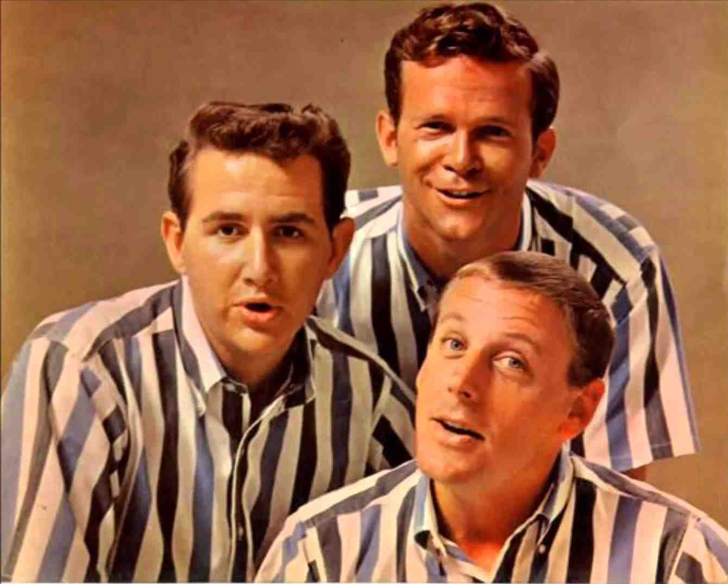
The Mixed Nuts
Set Y Last revised on 2016.08.29

Y01-Hallelujah!(K).pdf
Y02-Meet Me In St. Louis, Louis(KVF).2016.05.21.pdf
Y02-Meet Me In St. Louis, Louis(KVM).2016.05.21.pdf
Y03-How Deep Is The Ocean(KVF).2013.11.26.pdf
Y03-How Deep Is The Ocean(KVM).2013.11.26.pdf
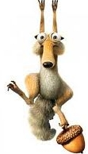
Y04-Istanbul(KVF).2016.05.21.pdf
Y04-Istanbul(KVM).2016.05.21.pdf
Y05-Cuddle Up A Little Close(KVF).2013.11.26.pdf
Y05-Cuddle Up A Little Close(KVM).2013.11.26.pdf
Y06-Helena Polka(KV).2016.08.29.pdf
Y07-I Need You Now(KVF).2016.08.29.pdf
Y07-I Need You Now(KVM).2016.08.29.pdf
Y08-Give My Regards To Broadway(KVF).2016.08.29.pdf
Y08-Give My Regards To Broadway(KVM).2016.08.29.pdf
Y09-Where Have All The Flowers Gone(KVD).2016.08.29.pdf
Y10-Tom Dooley(KVD).2016.05.21.pdf
Y11-M.T. A.(KV).2016.05.21.pdf
Y12-Oh, My Papa(KVF).2014.03.23.pdf
Y12-Oh, My Papa(KVM).2014.03.23.pdf
Y13-In The Wee Small Hours Of The Morning(KVF).2015.04.20.pdf
Y13-In The Wee Small Hours Of The Morning(KVM).2015.04.20.pdf
Y14-I Can't Believe That You're In Love With Me(KVF).2016.05.21.pdf
Y14-I Can't Believe That You're In Love With Me(KVM).2016.05.21.pdf
Y15-Sunrise, Sunset(KVD).2016.08.29.pdf
Y16-I Get A Kick Out Of You(KVF).2016.05.21.pdf
Y16-I Get A Kick Out Of You(KVM).2016.05.21.pdf
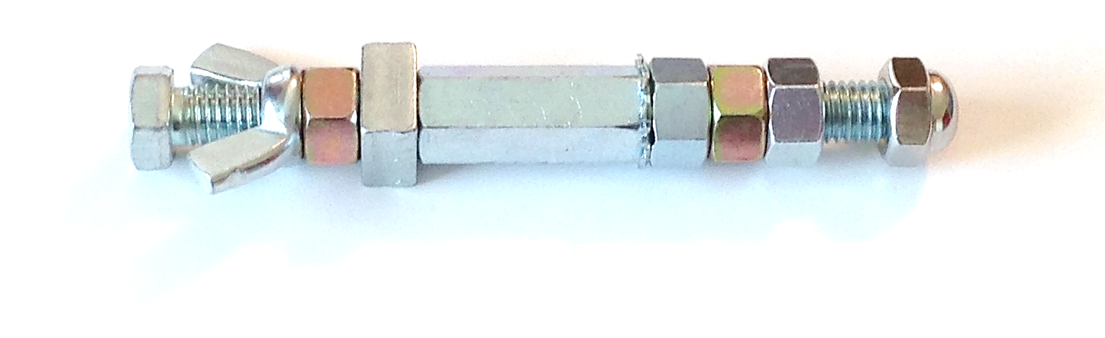
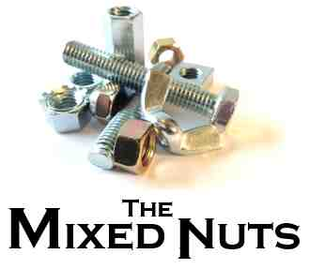
Y17-That's A-Plenty(K).2013.11.26.pdf

